BANK LOAN REPORT

DASHBOARD 1:
BANK LOAN REPORT | SUMMARY
KPIS:
- Total Loan Applications:
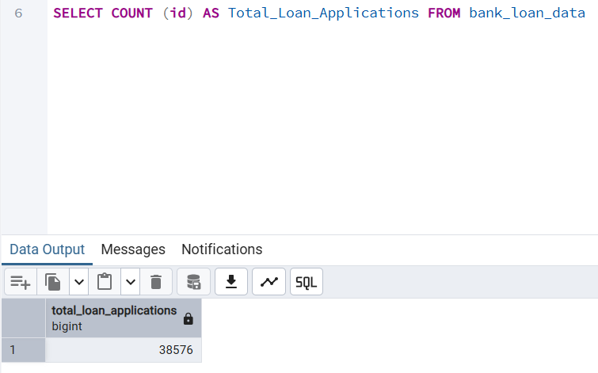
- MTD Loan Applications
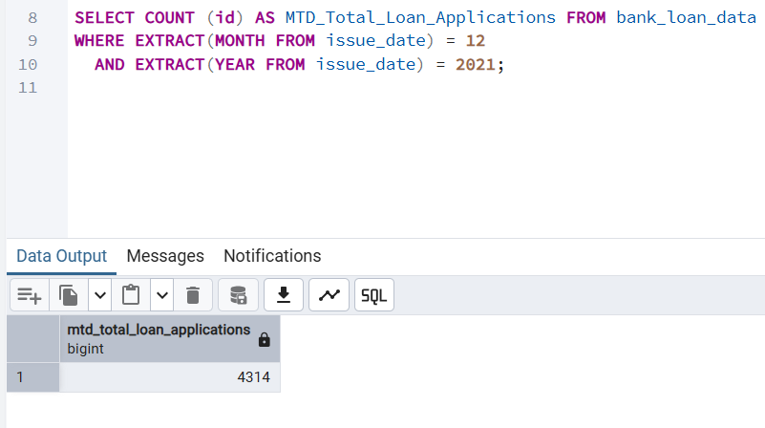
- PMTD Loan Application
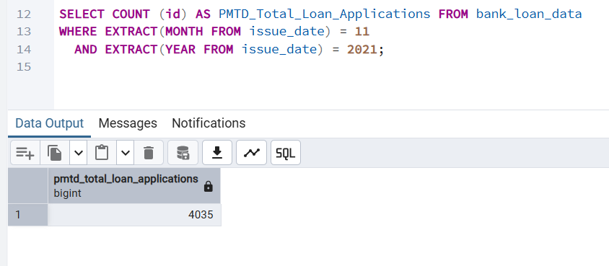

- Total Funded Amount
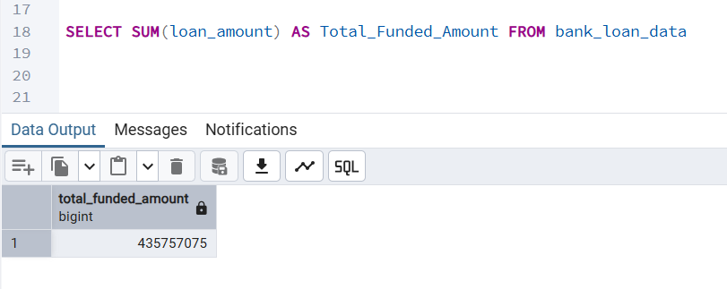
- MTD Total Funded Amount

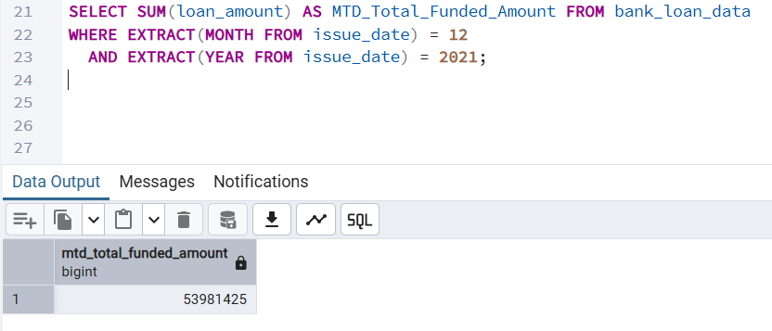

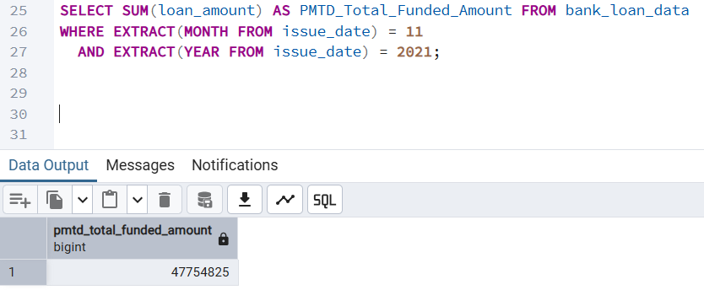
- PMTD Total Funded Amount

- Total Amount Received
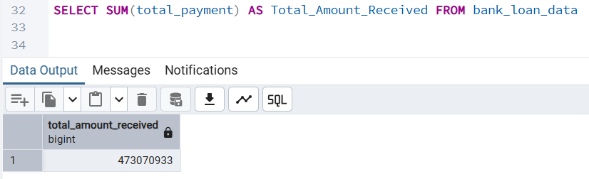

- MTD Total Amount Received
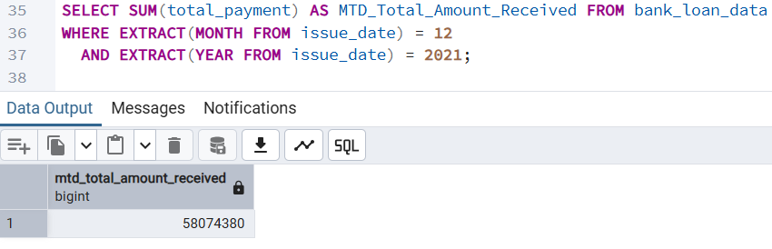

- PMTD Total Amount Received
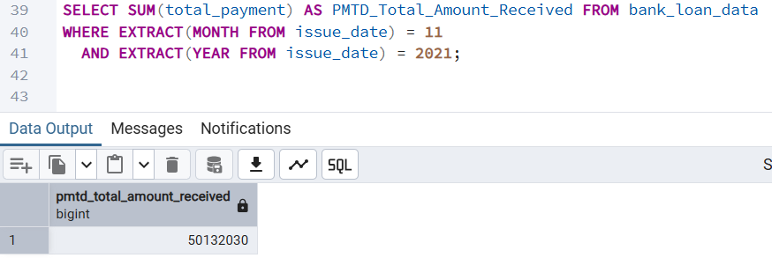

- Average Interest Rate
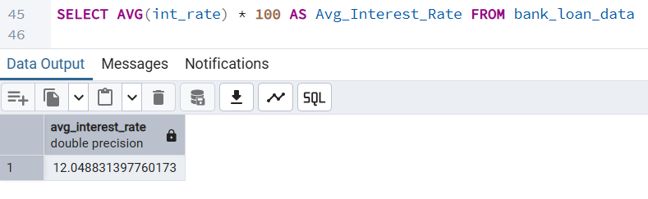

- MTD Average Interest Rate
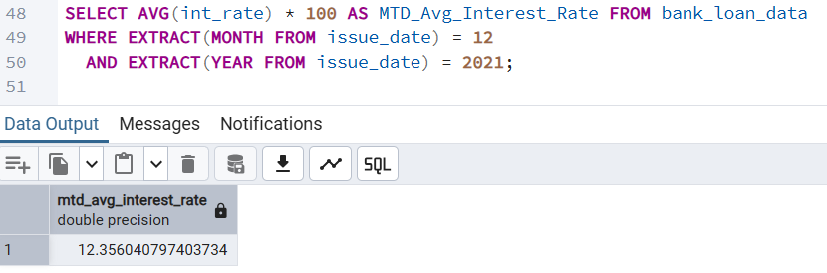

- PMTD Average Interest Rate
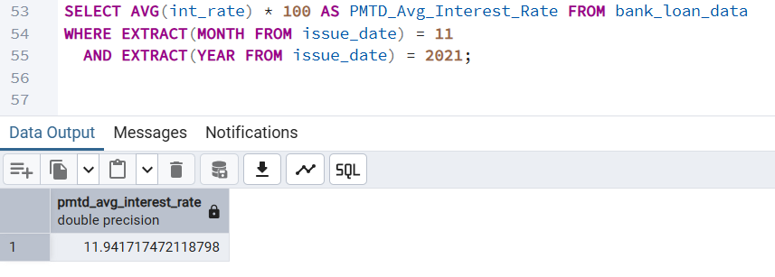

- Avg DTI
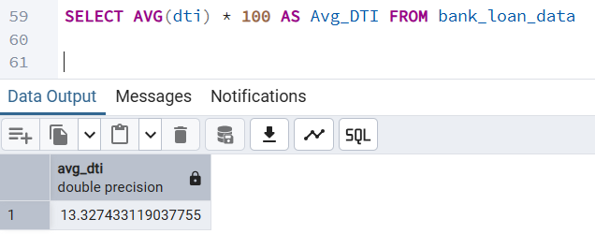

- MTD Avg DTI
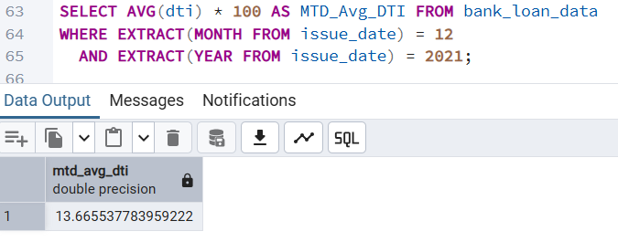

- PMTD Avg DTI
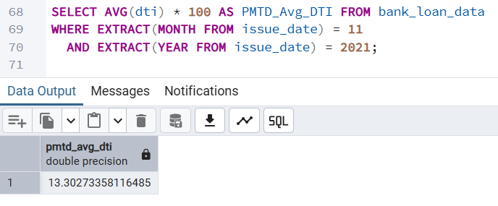

- Good Loan Percentage
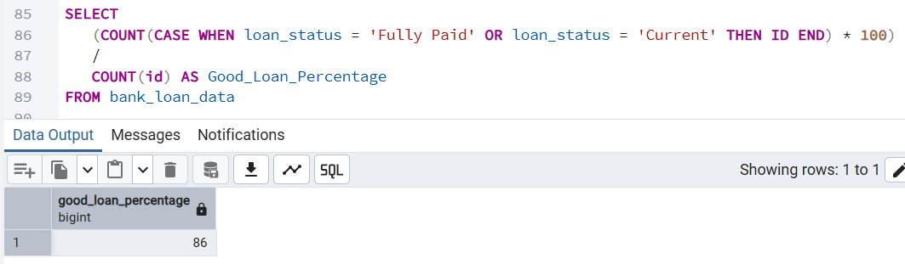

- Good Load Applications
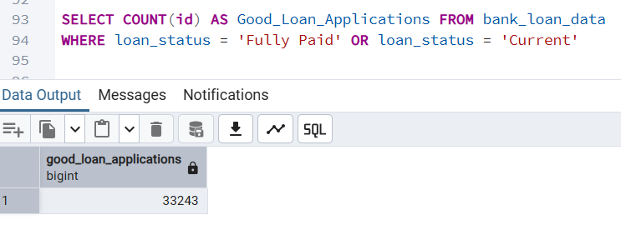
- Good Loan Funded Amount
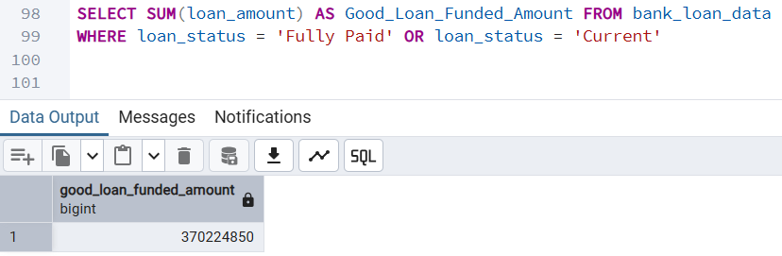

- Good Loan Amount Received
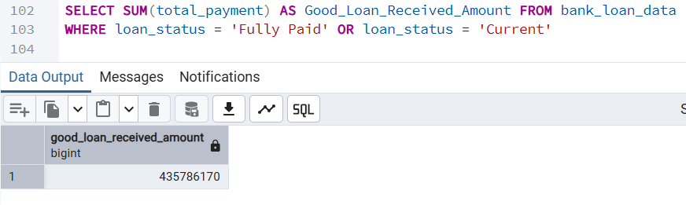

- Bad Loan Percentage
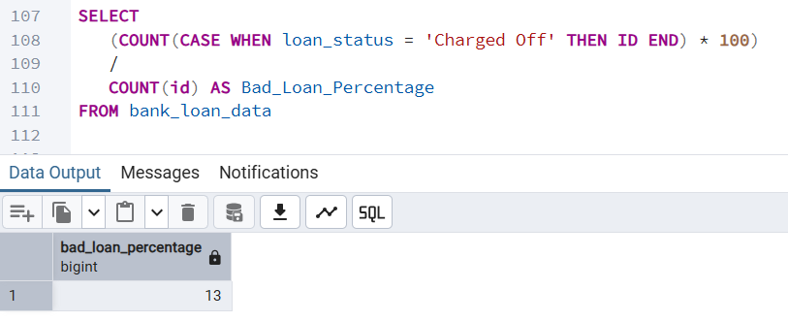

- Bad Loan Applications
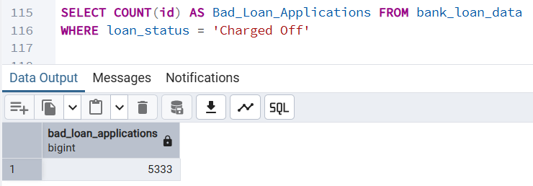

- Bad Loan Funded Amount
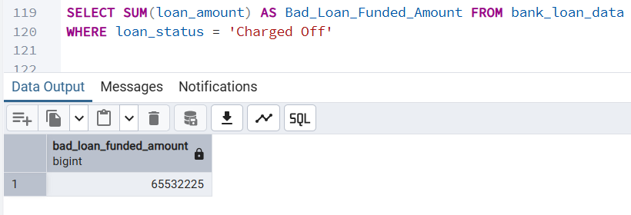

- Bad Loan Amount Received
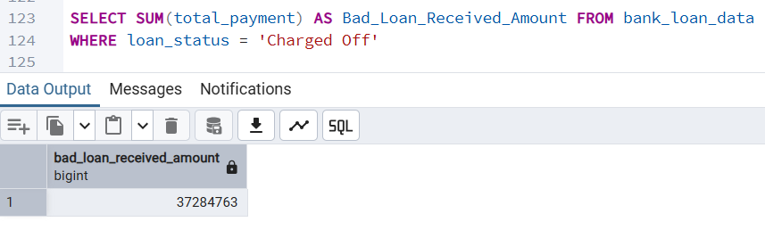

- LOAN STATUS
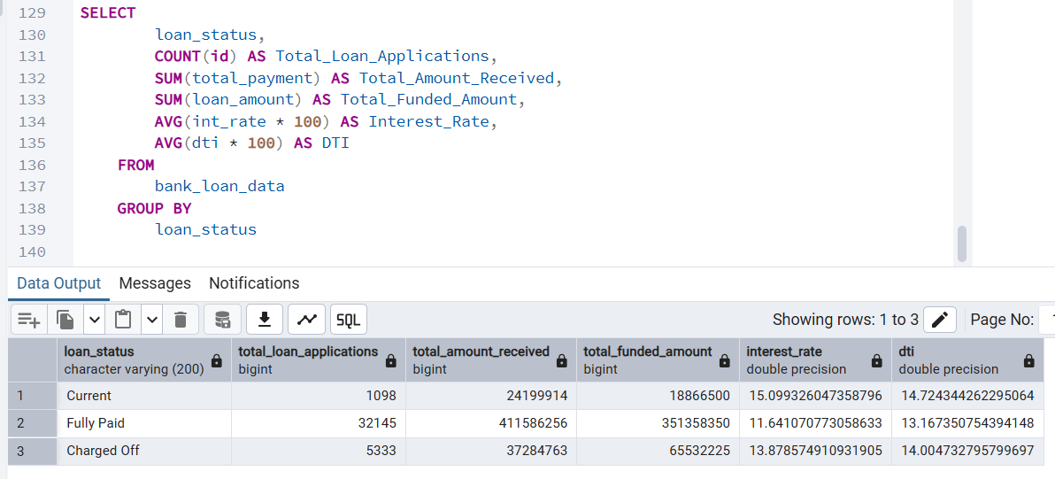

- MTD LOAN STATUS
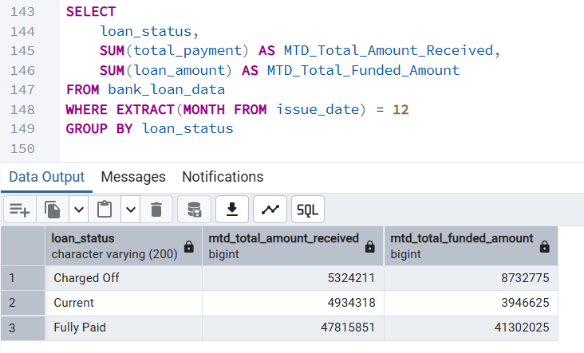

DASHBOARD 2:
BANK LOAN REPORT | OVERVIEW

- MONTH
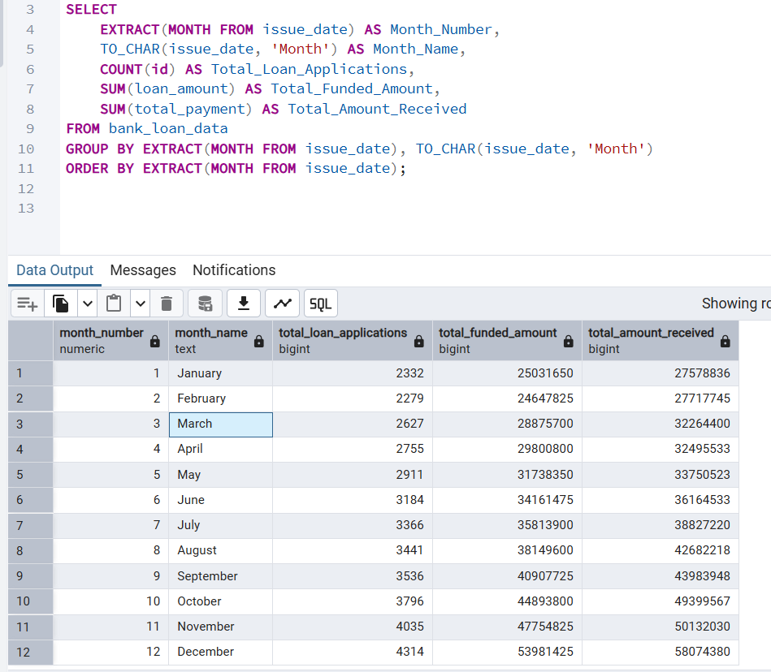

- STATE
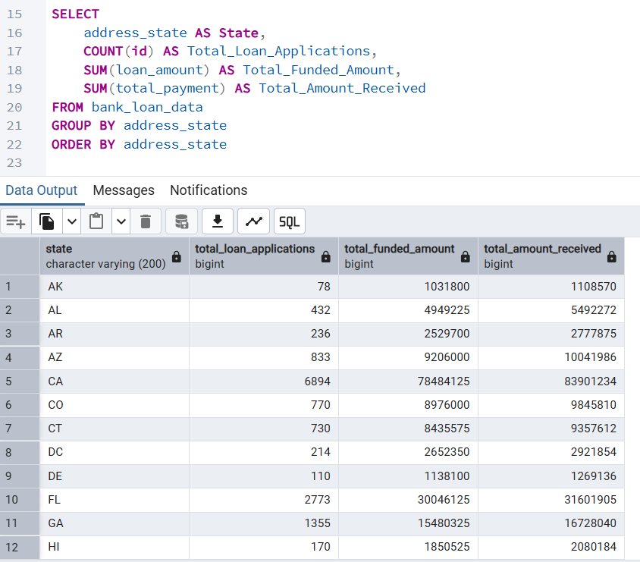
- TERM
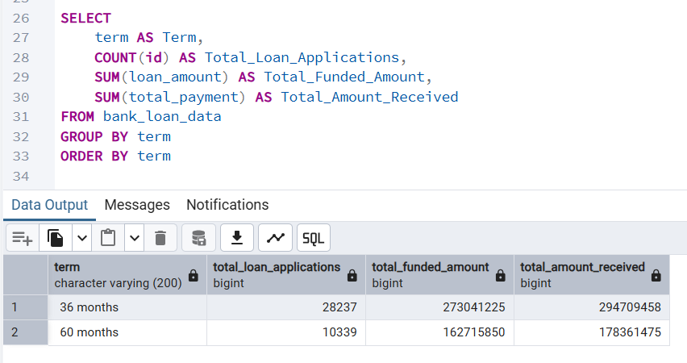
- EMPLOYEE LENGTH
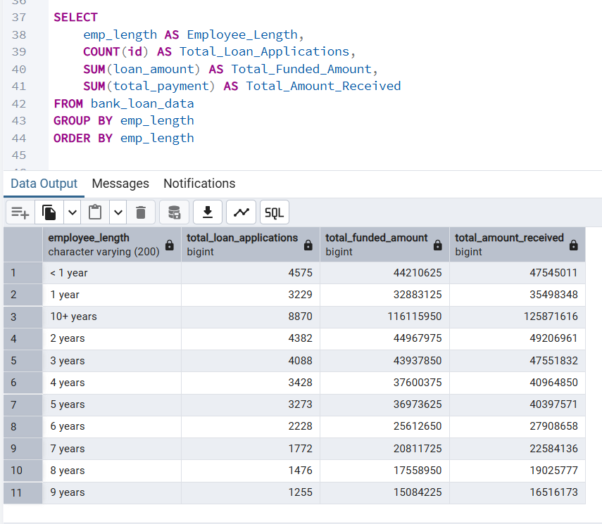

- PURPOSE
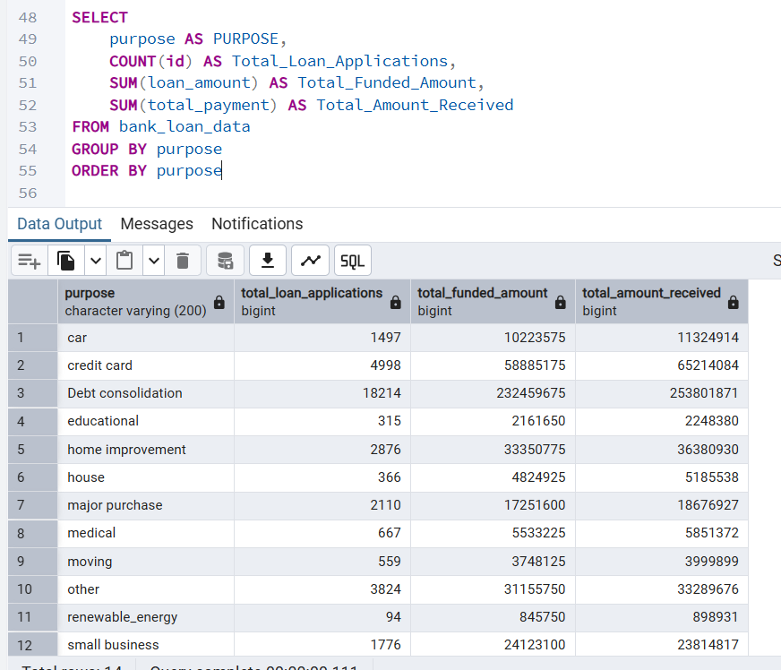

- HOME OWNERSHIP

